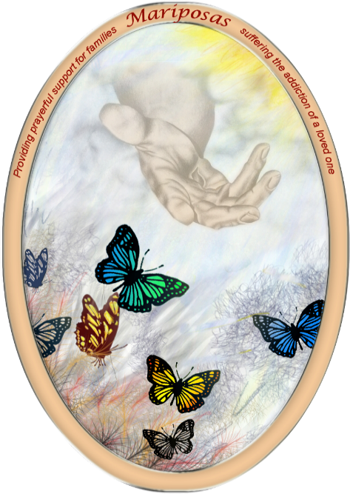
Mariposas Facilitator Training
WHAT Mariposas is a support group for families with loved ones suffering an addiction.
The workshop will equip ministers to lead a Mariposas Support Group in their parish.
Content will include information on addiction and practice in ways to:
1. Get loved ones to reduce or eliminate substance abuse behaviors
2. Get resistant loved ones into substance abuse treatment
3. Decrease depression, anxiety, & anger in families who struggle with this disease.

WHO Adults, 18 years and older, with pastor approval

WHEN Saturday, February 9, 9:00 AM to 4:00 PM

WHERE Parish Hall, San Juan Bautista, Ohkay Owingeh Pueblo, New Mexico

WITH Ms. Cathy Alarid, founder of Mariposa; Mr. Brian Serna, LPCC, LADAC, of Serna Solutions in Santa Fe.

To register, call the Family Life Office at 505-831-8117 or email the office at yduran@archdosf.org before Wednesday, February 6, 2019.

Lunch will be provided, compliments of: The ASF Annual Catholic Appeal and the Catholic Foundation

